HANA
Module - 4 LAB BOOK

Table of Contents
Table of Contents 2
Getting Started 3
Lab 1-1 Execute Queries in HANA Modeler using SQL 4
Lab 2-1 Execute ADBC Programs 6
Lab 3-1 Create Calculation Views using Script 7
Lab 3-1 ABAP on HANA 8
Lab 5-1 Create CDS Views 9
Lab 6-1 Create CDS with ALV 11
Appendix – A – Tables created 12

Getting Started

Overview
This lab book is a guided tour for learning SAP HANA. It comprises of assignments to be done. Refer the demos and work out the assignments given by referring the case studies which will expose you to work with Java applications.

Setup Checklist for SAP HANA
Here is what is expected on your machine in order to work with lab assignment.
Minimum System Requirements
- Intel Pentium 90 or higher (P166 recommended)
- Microsoft Windows 2010 or higher.
- Memory: (8GB or more recommended)

Please ensure that the following is done:
- SAP GUI is installed
- Connection to the SAP Server and HANA Server
- Java, Eclipse configured

Lab 1-1 Execute Queries in HANA Modeler using SQL
Goals | - How to use Execute Queries in HANA Modeler using SQL
Time | 4 hours
Lab Setup | Connectivity to SAP server and HANA Server  Login details for connecting to SAP server and HANA server

Data Query Language.
Use SQL in HANA Modeler to solve the below queries.
- List the Name and Designation code of the staff who have joined before Jan 2003 and whose salary range is between 12000 and 25000. Display the columns with user defined Column headers. Hint: Use As clause along with other operators
- List the staff code, name, and department number of the staff who have experience of 18 or more years and sort them based on their experience.
- Display the staff details who do not have manager. Hint: Use is null
- Display the Book details that were published during the period of 2001 to 2004. Also display book details with Book name having the character ‘&’ anywhere.
- List the names of the staff having ‘_’ character in their name.
- Write a query to display the following output. Query the Department_Master Table.
Hint: Use Case, End case.
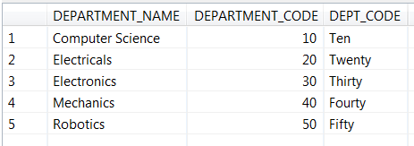
- Write a query to display the following output. Query the Staff_Master Table.
Hint: Use Case, End case.
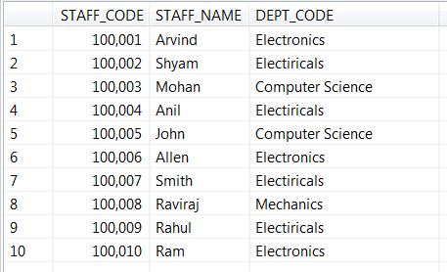

Group Functions:
- Display the Highest, Lowest, Total & Average salary of all staff. Label the columns Maximum, Minimum, Total and Average respectively for each Department code. Also round the result to the nearest whole number.
- Get the Department number, and sum of Salary of all non-managers where the sum is greater than 20000.

Joins and Subqueries
- Write a query which displays Staff Name, Department Code, Department Name, and Salary for all staff who earns more than 20000.
- Display Staff Code, Staff Name, Department Name, and his manager’s number and name. Label the columns Staff#, Staff, Mgr#, Manager.
- Create a query that will display Student Code, Student Name, Book Code, and Book Name for all students whose expected book return date is today.

Write a program in SE38 to retrieve records from zdept_Mas and zstaff_Master.

Retrieve Staff_code, Staff_Name and Staff_Sal from zstaff_Master.
Retrieve Dept_code Dept_Name from zdept_Mas.
Download the contents on a local file on your machine.

Lab 2-1 Execute ADBC Programs
Goals | - How to use execute ADBC programs in SAP GUI
Time | 4 hours
Lab Setup | Connectivity to SAP server and HANA Server  Login details for connecting to SAP server and HANA server
- Write select queries to:
  - List the Name and Designation code of the staff who have joined before Jan 2003 and whose salary range is between 12000 and 25000.
  - Display Staff Name, Department Code, Department Name, and Salary for all staff who earns more than 20000.
  - Display Staff Name, Department Code, Department Name, and Salary for all staff. Use Case End Case .
If the salary is between 15000 and 25000 then Grade should be ‘Low’
If the salary is between 25001 and 40000 then Grade should be ‘Medium’
If the salary is between 45001 and 65000 then Grade should be ‘High’
  - Display the Empno and Role from ZROLE1 and ZROLE2 tables.
Hint: Use Union and Union All.
Use SQL - HANA Modeler to solve the above queries.
- Do the above queries using ADBC Programs.
Write separate programs in SE38 and execute it.
- Write a report to display sum of salary dept wise. Use the zstaff_master table.
Hint: use Internal tables control break statements.
- Write an SQL query to do the above.
- Write an ADBC program for the above SQL Query.

Lab 3-1 Create Calculation Views using Script
Goals | How to Create Calculation Views using Script
Time | 4 hours
Lab Setup | Connectivity to SAP server and HANA Server  Login details for connecting to SAP server and HANA server
- Create calculation view as below.
ZXXXXXX_calc view which displays sum of staff_sal dept_code wise.
Where XXXXXX is your employee code.
Use the zstaff_master table.
- Write an ADBC program to consume the above calculation view.
- Create an external view for the above calculation view. Name the external view as ZXXXXXX_Ext_View where XXXXXX is your employee code
- Write a SE38 program to see the contents of the above external view.
- In the HANA development perspective, create a new procedure which retrieves all records and all fields from the table zstaff_master. Follow appropriate naming conventions to name the procedure.
- View the above procedure in HANA Modeler and execute it there.
- Write down an ADBC program which executes the above procedure.
- In the HANA development perspective, create a new procedure which retrieves sum of staff_sal dept_code wise. Name the procedure as your initials1.procedure.
Hint: Create Local Table Types.
- View the above procedure in HANA Modeler and execute it there.
- Write down an ADBC program which executes the above procedure.

Lab 3-1 ABAP on HANA
Goals | How to use new ABAP Syntax
Time | 4 hours
Lab Setup | Connectivity to SAP server and HANA Server  Login details for connecting to SAP server and HANA server
- Display the sum of 2 numbers using inline declaration.
- Concatenate your first name and last name separated by a space into a variable fullname. Display the fullname.
- Select Staff Name, Department Code, and Salary for all staff into an Internal Table. Display the contents of the Internal table. Use the zstaff_master table.
- Create a copy of the above program(Assign 3). Modify it to retrieve the dept_name also. Use Join. Use the zstaff_master and zdept_mas tables.
Display the contents of the Internal table.
- Create a copy of the above program(Assign 4). Modify it to display the Grade as per the conditions mentioned below. Use Case End case.
If the salary is between 15000 and 25000 then Grade should be ‘Low’
If the salary is between 25001 and 40000 then Grade should be ‘Medium’
If the salary is between 45001 and 65000 then Grade should be ‘High’
- Select Staff Name, Department Code, hiredate and Salary for all staff into an Internal Table. Display the contents of the Internal table. Use functions to display the Staff Name in Upper Case and Lower Case. Display hiredate after adding 12 months.
Use the zstaff_master table.
- Create a copy of the above program(Assign 5). Read the 6th Record of the internal table. Use Index.
- Create a copy of t he above program(Assign 5). Read the record with staff_name as Allen or address as Mumbai. Use keys.
- Write a program to accept month number as a parameter. Display the Corresponding Month Name. Use Case EndCase.

Lab 5-1 Create CDS Views
Goals | How to Create CDS Views
Time | 4 hours
Lab Setup | Connectivity to SAP server and HANA Server  Login details for connecting to SAP server and HANA server

- Create a CDS view to select the following fields from zstaff_master
Staff_code, Staff_name, design_code, dept_code,staff_sal.
Preview the data.
- Write a SE38 program to view the contents of the above view.
Use the new ABAP syntax.
- Create a CDS view to select the following fields from zstaff_master and zdept_mas.
Staff_code, Staff_name, design_code, dept_code,dept_name and staff_sal.
Preview the data.
- Write a SE38 program to view the contents of the above view.
Use the new ABAP syntax.
- Create a CDS view to select the following fields from zstaff_master and zdept_mas.
Staff_code, Staff_name, design_code, dept_code,dept_name and staff_sal.
Use Case End Case as per the below criteria.
If staff_sal is between 15000 and 25000 then display as 'Low'
If staff_sal is between 25001 and 45000 then display as 'Medium'
If staff_sal between 45001 and 65000 then display as 'High
Preview the data.
- Write a SE38 program to view the contents of the above view.
Use the new ABAP syntax.
- Create a CDS view to view the contents of Zrole1 and Zrole2 tables.
Use Union and Union all. Preview the data.
- Refer to the view created in Assigment 1. Create a view on that by joining with the zdep_mas table. View the dept_name field also along with all the fields of the above view. Preview the data.
- Refer to the view created in Assigment 1. Extend this view by adding the fields STAFF_DOB and HIREDATE. Create another view for doing the above.

- Make a copy of the view created in Assignment 1. Modify it to use parameters for staff_code and staff_sal.

Lab 6-1 Create CDS with ALV
Goals | How to Create CDS Views with ALV
Time | 4 hours
Lab Setup | Connectivity to SAP server and HANA Server  Login details for connecting to SAP server and HANA server

Use a suitable ALV from the ALVs created in Lab 5
- Add a Print button to the ALV. Make use of the method SET_PRINT_ACTIVE
- Before the Standard fuctions.
- After the Standard functions.
- Disable 3 fields from the existing View .
- Enable the Sort operation on two fields in the ALV
- Disable the aggregate function on any field in the ALV.
- Set a suitable title to the ALV.
- Add the Show/Hide Search Bar Icon in the ALV. Make use of the method set_text_search_active

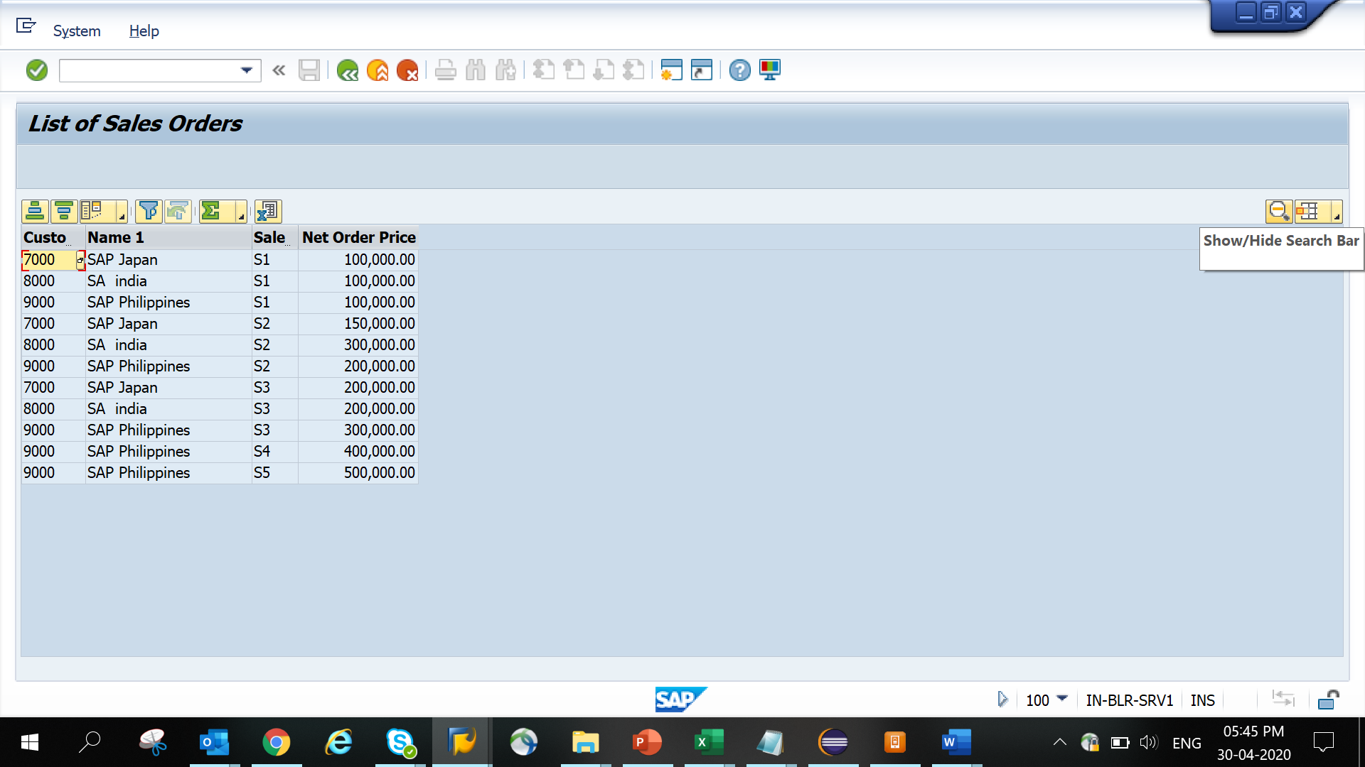

- Enable Alternate shading in the ALV
- Change the header field text of the primary key field to the text ‘PRIMARY_KEY’.
- Add tool tip text as ‘I am the primary key’ to the PRIMARY_KEY field

Appendix – A – Tables created
The following tables have been created. If the tables are not present, consult your trainer. Do NOT create the tables.
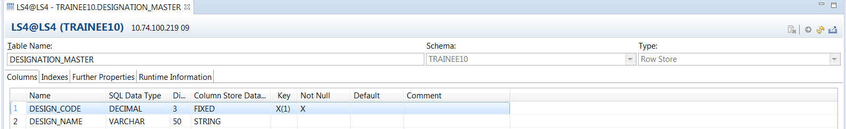
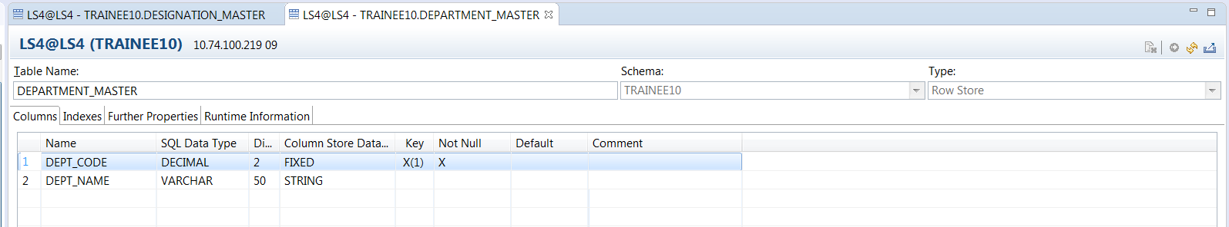
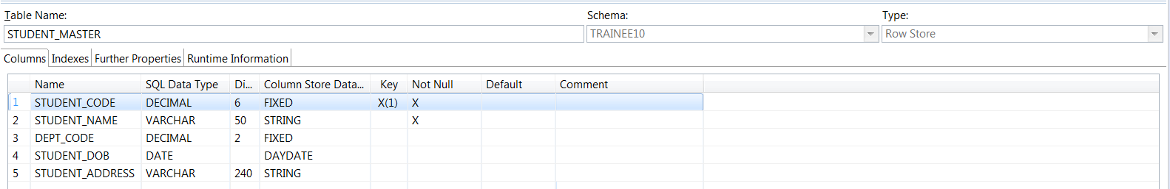
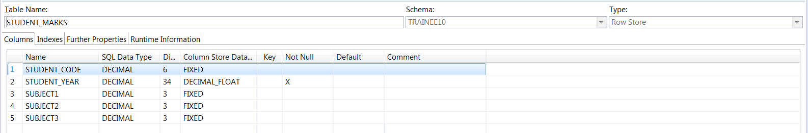
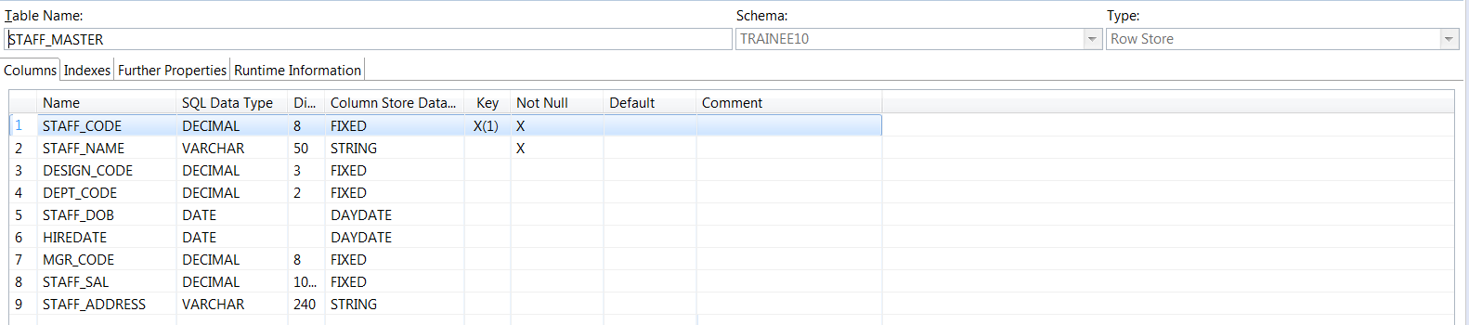
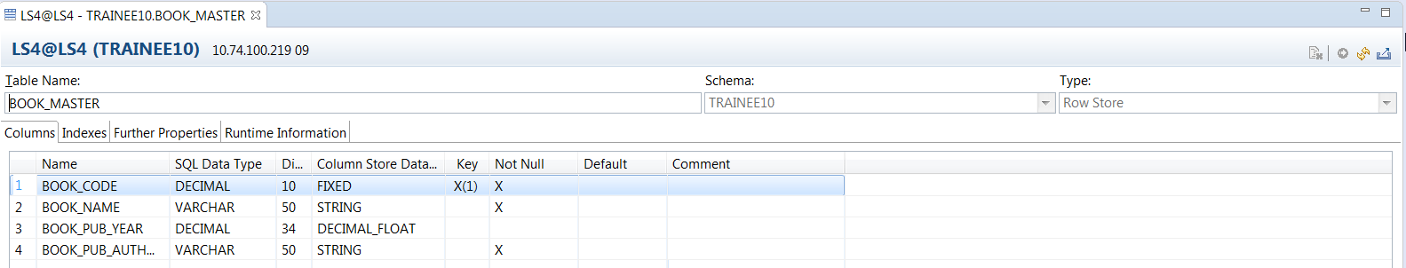
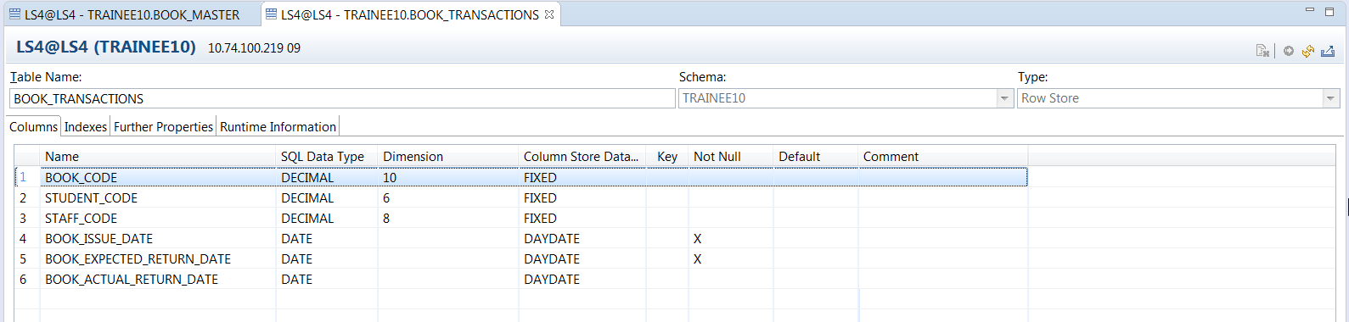
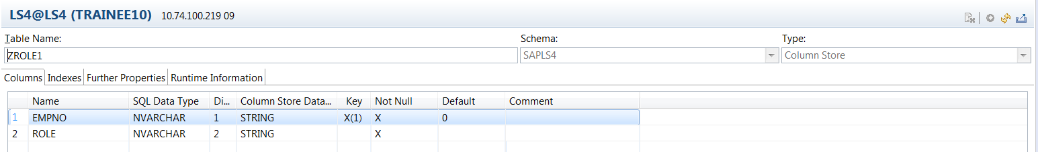
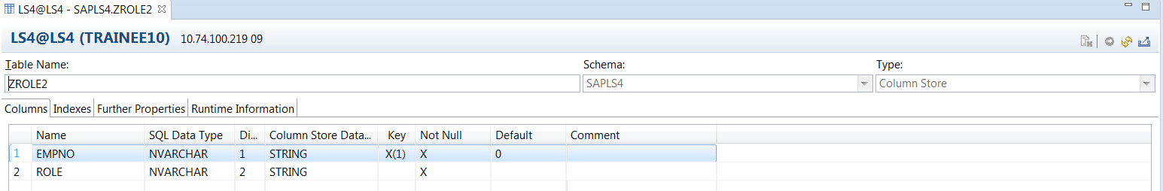
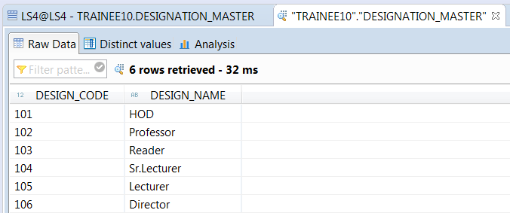
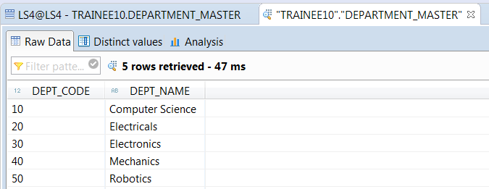

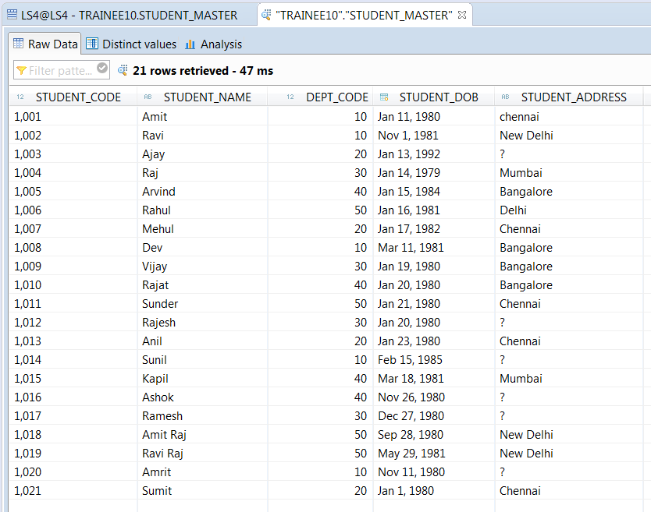

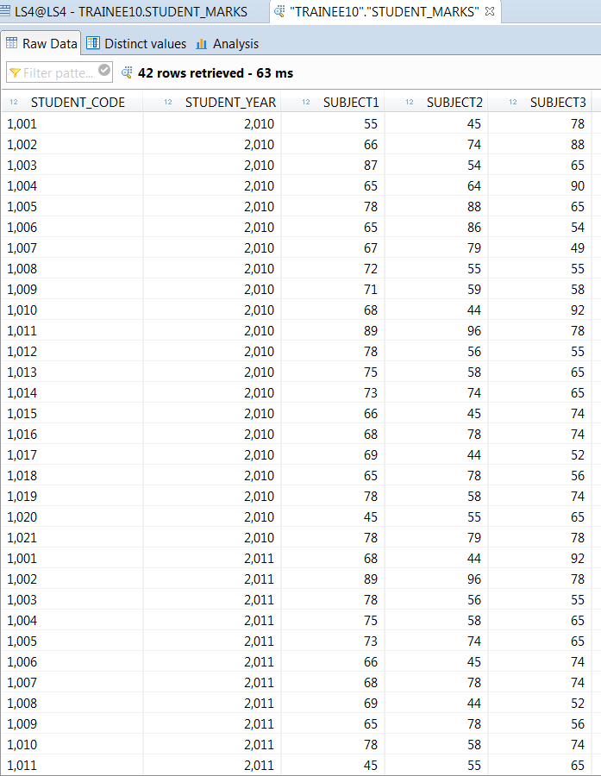

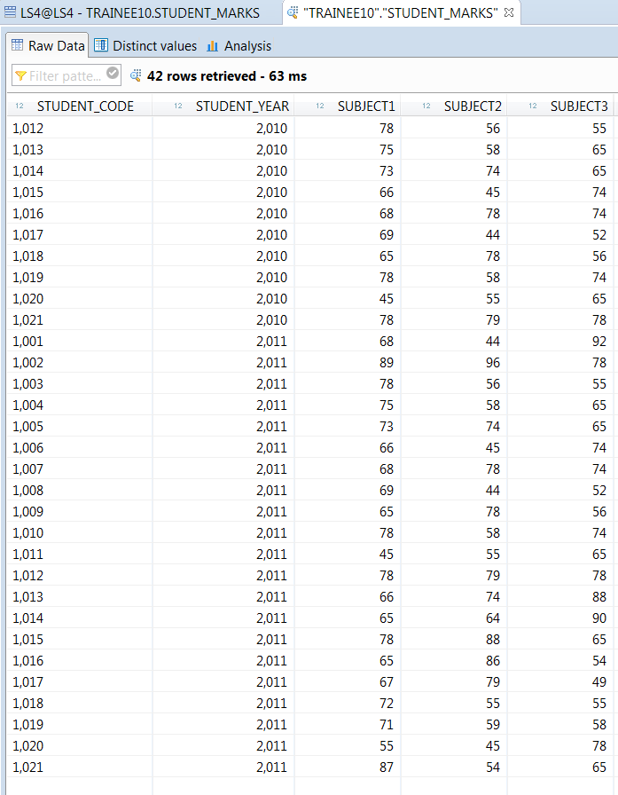

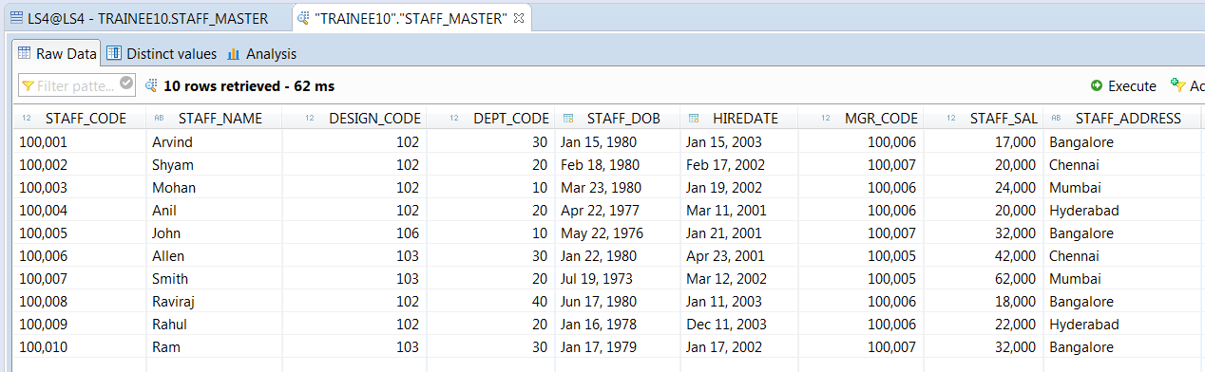

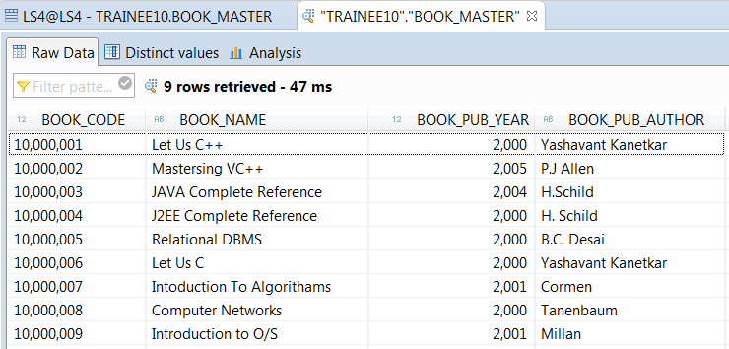

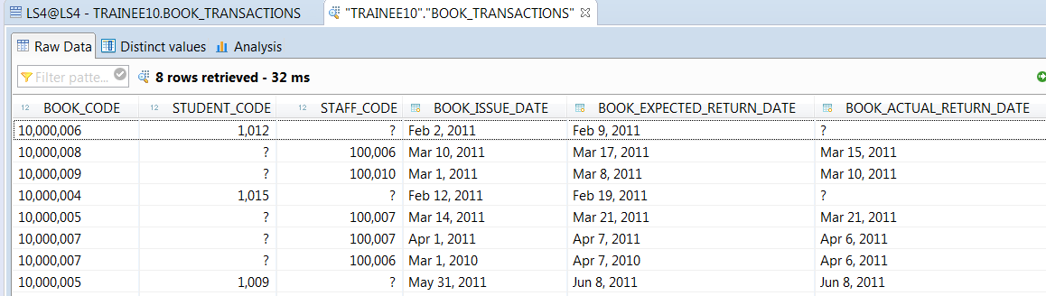

Note: ? Indicates No value for that field.
